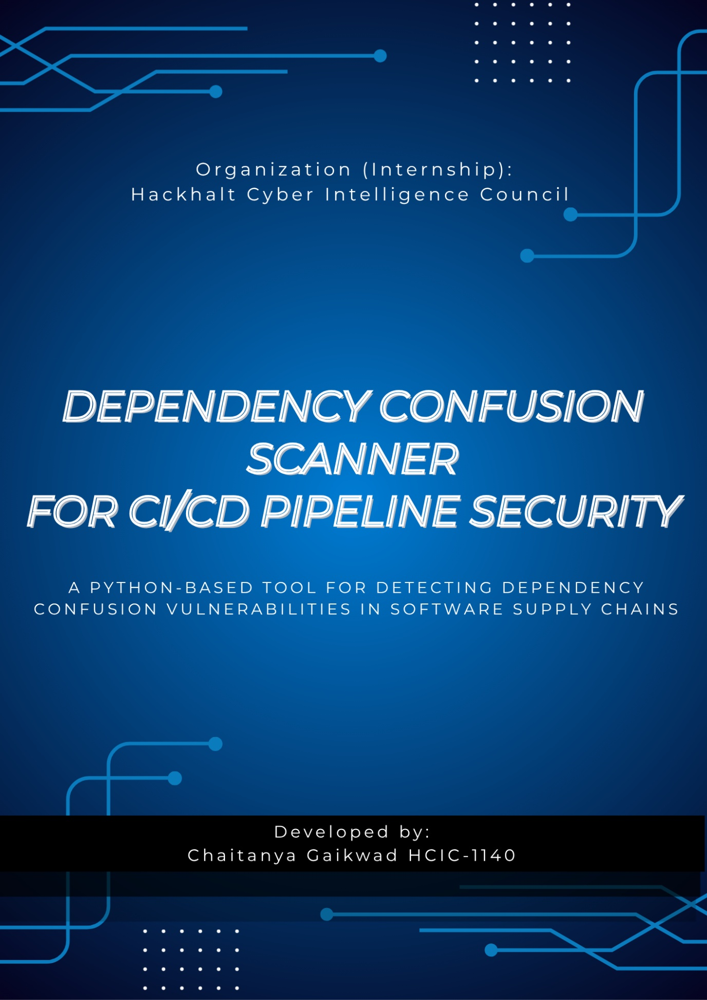

PROJECT TITLE: Static Code Scanner for CI/CD Pipeline Dependency Confusion Vulnerabilities
DATE: July 10, 2026
LEAD: Chaitanya Gaikwad Cyber Security Intern (HackHalt Internship Program)
STATUS: Completed Version 1.0
PROJECT LINK:

- Executive Overview
- Objective: The main objective of this project is to develop a Python-based Dependency Confusion Scanner that identifies possible dependency confusion vulnerabilities before software packages are installed. The tool helps developers detect risky dependencies by checking them against public package registries and an internal package list.

- The Challenge: Modern software projects use many third-party libraries from package managers such as PyPI, npm, and Maven. If an organization uses private package names, an attacker can publish a package with the same name on a public registry. If the package manager installs the public package instead of the private one, it can introduce malicious code into the application. This type of software supply chain attack is known as a Dependency Confusion Attack.
Most small projects do not verify whether their dependencies are safe before installation. This increases the risk of supply chain attacks.

- The Solution: This project provides a command-line security tool that scans dependency configuration files, extracts package names, checks public package registries, compares them with an internal package list, performs version comparison, and identifies possible dependency confusion risks.
The scanner supports multiple dependency formats, including Python (requirements.txt), Node.js (package.json), and Java Maven (pom.xml). After scanning, it generates a detailed JSON security report and returns an appropriate exit code, allowing the tool to be integrated into CI/CD pipelines.

- Business Impact: The developed scanner helps developers identify dependency confusion risks before deployment. It improves software supply chain security, supports secure development practices, and can be integrated into automated build pipelines. The project also provides clear mitigation recommendations, helping organizations reduce the chances of installing malicious packages.
- Technical Architecture & Stack
- Frontend: Not applicable (Command Line Interface application)
- Backend:
- Python 3
- Request Library
- JSON Processing
- XML Parsing
- Database:
- JSON files for configuring and reporting
- No External database required
- Infrastructure & Deployment:
- Local Python Environment
- GitHub Repository
- CI/CD Compatible through command-line execution and exit codes
- Public Registries Used:
- PyPI (Python)
- Npm Registry (Node.js)
- Maven Central Repository
- System Flow:
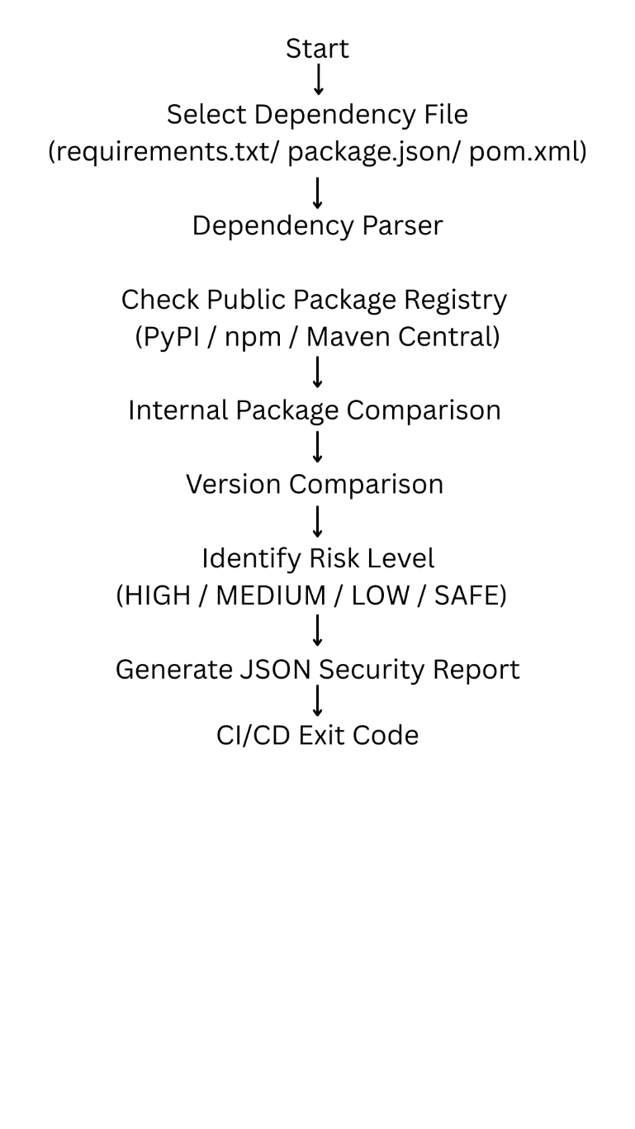
- Key Deliverables & Features
- Multi-Format Dependency Scanner: The scanner supports three commonly used dependency formats: requirements.txt, package.json, pom.xml
- Public Registry Verification: The tools check package information from PyPI, npm, Maven Central to determination whether packages already exist publicly.
- Internal Package Verification: The scanner compares dependency names against an internal package list to identify packages that are intended to remain private.
- Dependency Confusion Detection: The project detects situations where an internal package also exists on a public registry with a newer version, indicating a possible dependency confusion attack.
- Version Comparison: The scanner compares internal package versions with publicly available versions to identify higher-risk situations.
- Automated Security Report: After every scan, the project generates a structured JSON report containing findings, risk levels, summary statistics, and mitigation recommendations.
- CI/CD Integration: The scanner returns exit code 0 for safe scans and 1 when a high-risk dependency confusion vulnerability is detected. This allows the scanner to be integrated into automated build pipelines.
- Implementation of Highlights & Performance
- Security & Compliance: The project follows secure software development practices by validating dependencies before installation. It performs registry verification, internal package validation, version comparison, and provides mitigation recommendations to reduce supply chain security risks.
- Performance: The scanner performs dependency parsing and registry verification within a few seconds for sample projects. Since only dependency metadata is checked, the tool remains lightweight and suitable for local execution or CI/CD automation.
- Quality Assurance: The project was tested using multiple dependency formats:
  - Python (requirements.txt)
  - Node.js (package.json)
  - Java Maven (pom.xml)
- Challenges & Strategic Roadmap
- Primary Technical Hurdle: One of the main challenges was implementing reliable dependency confusion detection instead of only checking whether a package existed publicly. The project required comparing internal package information with public registry data and performing version comparison to identify realistic attack scenarios.
- Resolution: The project was divided into separate modules for parsing, registry communication, internal package validation, risk analysis, and report generation. This modular design made debugging easier and allowed support for multiple package ecosystems.
An internal package configuration file was introduced to simulate enterprise package inventories, making the dependency confusion detection more realistic.
- Next Step (Phase 2) (Future scalability or Feature additions):
- Add support for private package registries such as Artifactory,
- Nexus Repository, and GitHub Packages.
- Support package scopes and wildcard matching (for example, @company/*).
- Generate HTML and PDF security reports.
- Integrate directly with GitHub Actions for automated security scanning.

